**Topics: Descriptive Statistics and Probability**

1. Look at the data given below. Plot the data, find the outliers and find out $μ, σ, σ^{2}$

|  |  |
| --- | --- |
| **Name of company** | **Measure X** |
| Allied Signal | 24.23% |
| Bankers Trust | 25.53% |
| General Mills | 25.41% |
| ITT Industries | 24.14% |
| J.P.Morgan & Co. | 29.62% |
| Lehman Brothers | 28.25% |
| Marriott | 25.81% |
| MCI | 24.39% |
| Merrill Lynch | 40.26% |
| Microsoft | 32.95% |
| Morgan Stanley | 91.36% |
| Sun Microsystems | 25.99% |
| Travelers | 39.42% |
| US Airways | 26.71% |
| Warner-Lambert | 35.00% |

**Ans**:

**Step 1**. Copy paste above data into new excel file.

**Step 2**. Import the file into R.

**Step 3**. Perform following operations.

> library(readxl)

> company <- read_excel("company.xlsx")

> View(company)

> mean(company$`Measure X`)

[1] 0.3327133

> sd(company$`Measure X`)

[1] 0.169454

> var(company$`Measure X`)

[1] 0.02871466

**Step 4**. Plot the data.

> boxplot(x = company$`Measure X`, horizontal = TRUE)

From the Observations,

Morgan Stanley is an outlier of 91.36

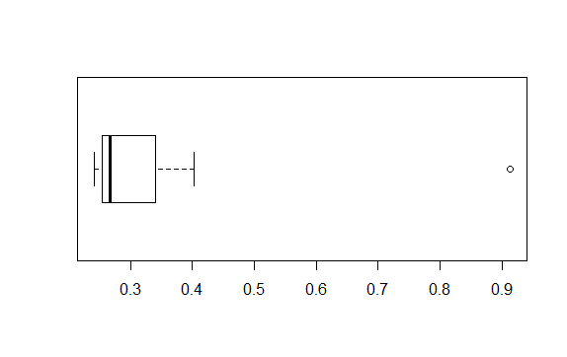



Answer the following three questions based on the box-plot above.

1. What is inter-quartile range of this dataset? (please approximate the numbers) In one line, explain what this value implies.

**Ans**: IQR= Q3 – Q1 = 12 – 5 = 7 , IQR represents middle 50% data.

1. What can we say about the skewness of this dataset?

**Ans:** Mean is less than median, so the box plot is Right skewed.

1. If it was found that the data point with the value 25 is actually 2.5, how would the new box-plot be affected?

**Ans**: The new Box plot will have no outliers in it.



Answer the following three questions based on the histogram above.

1. Where would the mode of this dataset lie?

**Ans**: Between Bins 4-6 and 6-8.

1. Comment on the skewness of the dataset.

**Ans**: Right skewed, as long tail towards Right.

1. Suppose that the above histogram and the box-plot in question 2 are plotted for the same dataset. Explain how these graphs complement each other in providing information about any dataset.

**Ans**: Both Plots give idea about skewness of the data, But

1. Box plot provides outlier values, which fails to provide by histogram.
2. Similarly histogram provides the frequency of datapoints, which fails to provide by box plot.
3. AT&T was running commercials in 1990 aimed at luring back customers who had switched to one of the other long-distance phone service providers. One such commercial shows a businessman trying to reach Phoenix and mistakenly getting Fiji, where a half-naked native on a beach responds incomprehensibly in Polynesian. When asked about this advertisement, AT&T admitted that the portrayed incident did not actually take place but added that this was an enactment of something that “could happen.” Suppose that one in 200 long-distance telephone calls is misdirected. What is the probability that at least one in five attempted telephone calls reaches the wrong number? (Assume independence of attempts.)

**Ans**: E: The call is misdirected

then probability of the event E is

P(E)= 1/200

Therefore,

Probability that at least one in 5 attempted call reaches the wrong number

= 1 - Probability that no attempted call reaches the wrong number

= 1 – P(E bar)

= 1 – (199/200)* (199/200)* (199/200)* (199/200)* (199/200)

= 1 - (199/200)^5

= 0.025

Probability that at least one in 5 attempted call reaches the wrong number = 0.025

1. Returns on a certain business venture, to the nearest $1,000, are known to follow the following probability distribution

|  |  |
| --- | --- |
| x | P(x) |
| -2,000 | 0.1 |
| -1,000 | 0.1 |
| 0 | 0.2 |
| 1000 | 0.2 |
| 2000 | 0.3 |
| 3000 | 0.1 |

1. What is the most likely monetary outcome of the business venture?

**Ans**: 2000

1. Is the venture likely to be successful? Explain

**Ans**: Yes, there are 60% chances of getting a positive return and 20% chances of negative returns or debts.

1. What is the long-term average earning of business ventures of this kind? Explain

**Ans**: Long term returns = ((-2000*1)+ (-1000*1)+ (1000*2)+ (2000*3)+ (3000*1) / 6) = 8000/6 = 1333

1. What is the good measure of the risk involved in a venture of this kind? Compute this measure

**Ans**: Good measure is, Positive returns (profits) probability tends to be more than negative returns (loss). i.e. 60% probability of profits and 20% probability of loss.